**National Intelligence and Security Discovery Research Grants**

Final Reports Instructions  
RMS user guide and Instructions

*Guidelines for completing Final Reports for   
National Intelligence and Security Discovery Research Grants (NISDRG)*

Table of contents

Submission of Final Reports: Information to note 3

When to submit a Final Report. 3

Final Report Extensions 3

Waive requests 3

Administration of Final Reports in RMS 3

Certification and accuracy of information 4

Updating of Final Reports once submitted. 4

Starting a Final Report in RMS 5

Searching for and editing a Final Report 5

Research Office Reports 5

If a Final Report is not appearing in RMS 5

Final Report state (status) 5

Completing the Final Reports Form Parts 6

Mandatory Questions 7

How to add multiple answers and remove answers within questions. 7

Part A – Project Details 9

Part B – Research Activities 11

Part C – Project Outputs 18

Part D – Project Outcomes 24

Part E – Research Impacts 26

Part F – Budget and expenditure 28

# Submission of Final Reports: Information to note

National Intelligence and Security Discovery Research Grants (NISDRG) requires that a Final Report be submitted for each funded Project. These instructions provide information to assist Research Office staff and Project participants in the completion and submission of NISDRG Final Reports in the Research Management System (RMS).

The Project Leader (first named participant) is responsible for the completion of the Final Report and its submission to the Administering Organisation’s Research Office. All *listed* active participants and Research Office staff have full edit access to the Final Report. Research Office Delegates are responsible for the certification of the form and submission of Final Reports.

If, after consulting this document, there are any queries regarding completing a Final Report form in RMS, please contact the Administering Organisation’s Research Office.

**Please note**: Paper copies of Final Reports will not be accepted.

## When to submit a Final Report

Final Reports are due six months after all NISDRG funding has been last expended. This includes expenditure of all funding paid and approved carryovers. The Final Report due date based upon the Project’s end date provided by the Administering Organisation’s Research Office during the End of Year Reporting Process each year, or as a result of any Variation of Grant Agreement (Variation) changes. Final Reports must not be submitted prior to completion of the Project. Due dates for Final Reports can be found within the Project details page in RMS.

## Final Report Extensions

Extensions for Final Reports can be requested via the Administrating Organisation’s Research Office. The request must note the Project Number and explain the extenuating circumstances. The Research Office can then submit the request to Research Grants Services (RGS) via an email.

**Please note:** Requests for an extension to the Final Report due date will only be reviewed if received from the Research Office of the Administering Organisation. Requests from researchers or other Participating Organisations will not be accepted.

## Waive requests

To request a Final Report to be waived, email the Administrating Organisation’s Research Office with the Project Number and a justification as to why the request is being made. The Research Office can then submit the request to RGS.

**Please note:** Waive requests for Final Reports will only be reviewed if:

* no money was expended;
* the Project’s duration was less than 12 months; or
* suitable justification is provided for the request.

Requests to waive Final Reports due to lack of response from investigators will not be considered.

## Administration of Final Reports in RMS

NISDRG Final Reports can only be accessed and managed through the relevant RMS portal. For general instructions on how to use RMS, please refer to the [RMS User Guide](http://www.arc.gov.au/rms-information) available on the ARC website.

## Certification and accuracy of information

Final Reports must be checked and certified by the Research Office Delegate, before they can be submitted. Research Office Delegates are required to certify that the Project has complied with the relevant schemes Grant Guidelines and Grant Agreement, and that all information provided within the Final Report is accurate and up to date.

Final Reports cannot be submitted unless they have been certified by a Delegate. The ‘Submitted to Research Office (Valid)’ state will appear against each Report which is ready to be certified. Once certified, the state of Final Reports will appear as ‘Research Office Certified’ and can then be submitted by Research Office staff.

The following prompt will appear once the ‘Certify Final Report’ button has been selected:

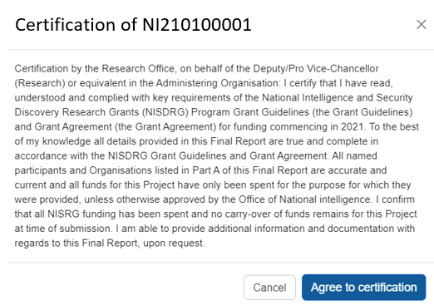

**Please note:** information collected in the NISDRG Final Reports is used to determine whether Projects have reached satisfactory completion. Statistical information collected in Final Reports enables the NISDRG Program to account for public funding of research and to promote the value of research to the Australian community. As such, RGS reserves the right to reject Final Reports, based on unsatisfactory completion, or to seek further clarification on information submitted or the lack thereof.

Please check that all of the information contained in the Final Report is accurate and that all required questions are completed as comprehensively as possible.

## Updating of Final Reports once submitted.

If the Project Leader needs to edit a Final Report after submission, Research Officers can request that the Final Report is de-submitted back to them until it has been approved in RMS. Once a report is assessed and approved in RMS further edits to the report will not be permitted.

## Starting a Final Report in RMS

1. Login to the relevant RMS portal.

* ONI RMS portal [https://**rmsoni.**researchgrants.gov.au/](https://aus01.safelinks.protection.outlook.com/?url=https%3A%2F%2Frmsoni.researchgrants.gov.au%2F&data=05%7C02%7CARC-NISDRG%40arc.gov.au%7C9a2d3b4ace084fae4a3b08dc7ea2c3e9%7Cc75dbeeca1a549b48a3ac54972b1ce77%7C0%7C0%7C638524484738088816%7CUnknown%7CTWFpbGZsb3d8eyJWIjoiMC4wLjAwMDAiLCJQIjoiV2luMzIiLCJBTiI6Ik1haWwiLCJXVCI6Mn0%3D%7C0%7C%7C%7C&sdata=zNNe3uIejzGgk97V4FYIxn6U%2FuNL9iMDFaGD6eq7xzo%3D&reserved=0)
* Defence RMS portal: [https://**defence**.researchgrants.gov.au/](https://aus01.safelinks.protection.outlook.com/?url=https%3A%2F%2Fdefence.researchgrants.gov.au%2F&data=05%7C02%7CARC-NISDRG%40arc.gov.au%7C9a2d3b4ace084fae4a3b08dc7ea2c3e9%7Cc75dbeeca1a549b48a3ac54972b1ce77%7C0%7C0%7C638524484738101738%7CUnknown%7CTWFpbGZsb3d8eyJWIjoiMC4wLjAwMDAiLCJQIjoiV2luMzIiLCJBTiI6Ik1haWwiLCJXVCI6Mn0%3D%7C0%7C%7C%7C&sdata=PrJ4VadRL26GkObMrOmAkn8es7F4RstZEcPSm9OBN9Q%3D&reserved=0)

1. In the *Applicant Grant Management* module of the *Action Centre*, click the ‘Final Reports’ link.

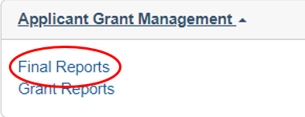

## Searching for and editing a Final Report

In the Final Reports tab, reports can be searched by selecting the relevant Scheme Round or Status from the allocated drop down lists or use the Search bar to search by Proposal/Title/Investigator/Organisation.

To edit a Final Report, click ‘Edit’ under the Actions column of the Final Report table. A Final Report may be edited by the Project participants and Research Office staff, however only the Project leader can submit it to the Research Office. Once it is submitted to the Research Office, only Research Office staff may edit the report. Once the Research Office has submitted the report, it can be viewed but not edited by Project participants and Research Office staff.

## Research Office Reports

A report showing the data on the Final Reports can also be extracted by Research Office staff, via the ‘Research Office Report API Config’ link, located within the *Reports* tab of the Action centre. Instructions on how to use the API can be accessed via this link.

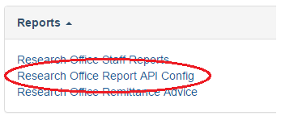

## A Final Report is not appearing in RMS

If the Final Report for a project is not appearing in RMS, please first check if the scheme round is appearing in the ‘Scheme Round’ drop-down list. If it is not appearing, the Report has not yet been made available for the Scheme Round.

## Final Report state (status)

The state of a Final Report relates to its progress status, and can be found on the second last column of the Final Reports tab. The State (Status) and their meanings are as follows:

| **State (status) type** | **Explanation** |
| --- | --- |
| **Draft** | The report has been created in RMS and is ready for editing. |
| **Ready to submit** | All mandatory questions have been completed in the draft report. |
| **Submitted to Research Office** | The Final Report has been submitted to the Research Office and not all mandatory questions have been answered |
| **Submitted to Research Office (Valid)** | The Final Report has been submitted to the Research Office, all mandatory questions have been answered and the report is ready to be checked and certified by the Research Office Delegate. |
| **Research Office Certified** | The Final Report has been certified by the Research Office Delegate and is ready to be submitted by Research Office staff. |
| **Submitted to ONI** | The Research Office has submitted the Final Report. |
| **Approved** | The Final Report has been Accepted. |
| **Waived** | The Final Report has been waived and the Lead Investigator not required to complete the report. |

## Completing the Final Reports Form Parts

Questions located in Parts A to Part E of the Final Report are generic across all schemes.

Within the heading of the form, the colour of the parts will be indicated as either red – meaning all mandatory questions have not been completed; or green – meaning all mandatory questions have been completed.

To begin filling out the Final Report, click on the relevant form part at the top of the screen beginning with Part A.

***Please remember to save regularly as you complete the form, using the ‘Save’ button located at the top right of the page.***

***The image of the 'Save' button.***

## Mandatory Questions

Some of the questions within the form are mandatory, meaning that they are required to be completed before the form part will validate. For these questions, the following warning will appear when there is an answer required before submitting the form:

This image shows what the 'Mandatory' validation looks like "This item must be answered"

## How to add multiple answers and remove answers within questions.

**Adding and removing multiple answers**

1. To enter multiple answer panels for a given question, select ‘Add answer’ at the bottom of the question or the questions answer panel.



1. To remove an answer panel, select the cross ‘X’ in the top right of the answer panel for the answer that needs to be removed.

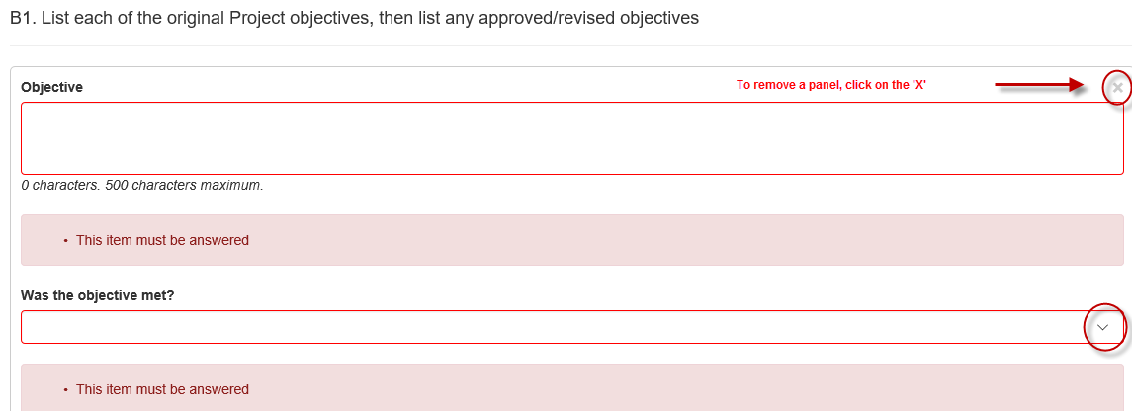

**Adding and removing an option**

1. To add, select the option from the drop-down menu or ‘search’ function and click ‘Add’.
2. To remove, select the ‘x’ beside the option that needs to be removed.

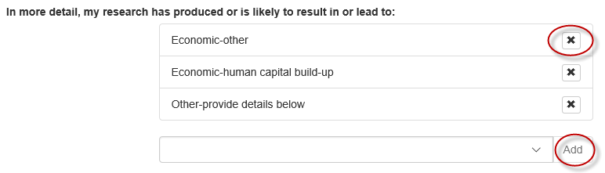

**Please note**: All options can only be added once. Click ‘Add’ otherwise the selection will be lost the next time ‘Save’ is hit.

# Part A – Project Details

**A1. Project Summary *(Auto-populated)***

This information is auto-populated from RMS and is a summary of the Project including funded amount, years funded and FoR/SEO codes. If there are any concerns regarding the information recorded within this section, please contact the Administering Organisation’s Research Office.

**A2. Named Participants *(Auto-populated)***

This information is auto-populated from RMS and will reflect the current status of all named participants. If there are any concerns regarding the information recorded within this section, please contact the Administering Organisation’s Research Office. If a change is required, a Variation will have to be submitted.

**A3. Named Participating Organisations *(Auto-populated)***

This information is auto-populated from RMS and will reflect the current status of all named organisations. If there are any concerns regarding the information recorded within this section, please contact the Administering Organisation’s Research Office. If a change is required, a Variation will have to be submitted.

**A4. Total Participating Organisation Contributions *(Auto-populated)***

This information is auto-populated from RMS and will reflect the contributions as currently listed within the Project. If there are any concerns regarding the information recorded within this section, please contact the Administering Organisation’s Research Office. If a change is required, a new Participating/Partner Organisation Agreed Contribution Report (POACR) will have to be submitted.

**A5. Total Partner Organisation Contributions *(Auto-populated)***

This information is auto-populated from RMS and will reflect the contributions as currently listed within the Project. If there are any concerns regarding the information recorded within this section, please contact the Administering Organisation’s Research Office. If a change is required, a new POACR will have to be submitted.

**A6. Did you leverage additional funding for this Project? *(Not Mandatory)***

This question is not mandatory and should only be answered if the project leveraged additional funding.

Please note that any additional funding from named organisations on the Project cannot be added at this question. Additional funding from named organisations should be advised in questions A4 and A5 and must be updated by submitting a revised POACR.

1. Manually type/insert the name of the organisation in which the additional funding was leveraged and select ‘Search’.
2. Once the name is found select the ‘Add’ button to add the appropriate organisation.

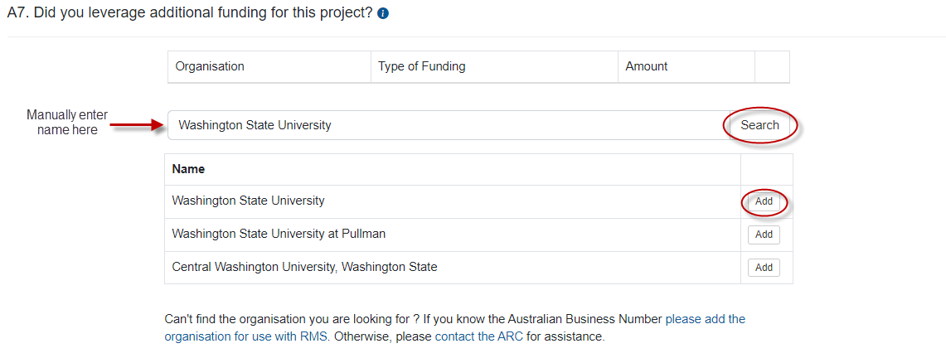

1. Select the ‘Cash’ or ‘In-kind’ funding type from the drop-down menu.
2. Insert ‘Amount’ of funding leveraged and tab or click outside of the table to populate.

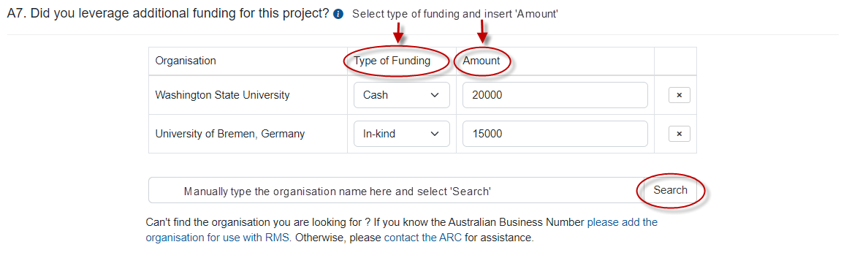

1. Repeat steps 1 to 4 to add additional organisations.

**A7. Please provide the Technology Readiness Level (TRL) that was achieved at Project completion and provide details to support the TRL achieved. *(Mandatory)***

The funding entity wants to know the progress you have made on the research. Select the TRL the research has reached and details to support this level and Provide a summary of the achievements of the project, of no more than 3000 characters (approximately 450 words).

**A8. Provide a brief summary of the achievements of this research project for public release. *(Mandatory)***

Provide a summary of the achievements of the project, of no more than 1000 characters (approximately 150 words). As this information may be posted on the RGS or funding entity website as the outcomes of the research, please use suitable language understandable by non-experts and do not disclose any information here that is commercial-in-confidence or may compromise the researcher’s ability to translate the research, such as intellectual property. Avoid the overuse of acronyms, quotation marks and upper-case characters.

# Part B – Research Activities

**B1. List each of the original Project objectives, provide details of how the objective was / was not achieved. *(Mandatory)***

Provide a written summary of no more than 3000 characters, for each original Project Objective and indicate if the objective was ‘met’ or ‘not met’.

Objectives will auto-populate as per the original proposal. Additional questions to be answered as detailed below:

1. Each objective as identified within the Project Proposal will auto-populate within this section. Select ‘yes’ or ‘no’ from the drop-down menu to indicate if the objective has been met or not met.

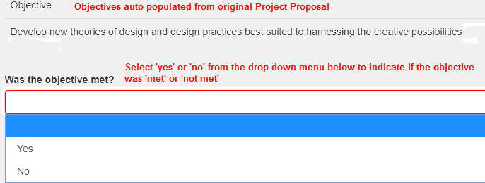

1. If yes, describe how the objective was met (maximum 3000 characters)
2. If no, provide further justification detailing why the objective was not met (maximum 3000 characters)
3. Repeat steps for each objective status.

**Changes to the original objective**

If an objective was revised, please select ‘no’ against the objective not achieved and provide further details and justification of the revised objective/s.

If an original objective was enhanced, please select ‘yes’ and provide details on how the objective was enhanced.

**B2. Did anything affect the satisfactory and timely progress or completion of the Project? If yes, briefly describe the events that affected progress or completion. *(Mandatory)***

A ‘Yes’ or ‘No’ answer is required. If ‘**Yes**’ is selected, provide a written summary of no more than 5000 characters, describing the events that affected the satisfactory and timely progress or completion of the Project. These events may include, but are not limited to:

* trouble finding PhD students/personnel required
* problems with salaried staff members
* illness of personnel/staff on the project
* problems which occurred with Partner Organisations
* delay in signing of Partner Organisation agreements
* personnel leaving the Project.

**Please note:** If changes should have been advised and approval granted, prior to reporting them in the Final Report then a retrospective Variation may be sought from the Administering Organisation’s Research Office. Additionally, if these changes are not approved, NISDRG may recover any funds associated with those changes.

**B3. Were there any Security Issues or Incidents during the Project Period? (*Mandatory*)**

A ‘Yes’ or ‘No’ answer Is required. If the project or its investigators encountered security issues, or requests from foreign entities to access the research please provide the details. (maximum 5000 characters)

**B4. Did your research project involve collaboration with Australian organisations?** **(*Mandatory*)**

A ‘Yes’ or ‘No’ answer is required. Select the Australian Organisation type from the drop-down box for each Organisation and provide details of each collaboration:

* Within your organisation
* Other Australian university
* Australian government agency (Commonwealth, State or Local)
* Australian Industry
* Australian not-for-profit
* Other Australian organisation.
* Other

Provide details of the collaboration, of no more than 5000 characters (approximately 450 words).

**B5. Did your research project involve collaboration with overseas organisations?** (*Mandatory*)

A ‘Yes’ or ‘No’ answer is required. Select the Overseas Organisation type from the drop-down box for each Organisation and provide details of each collaboration

* Overseas university
* Overseas government agency
* Overseas industry
* Overseas not-for-profit
* Other overseas organisation.

Provide details of the collaboration, of no more than 5000 characters (approximately 450 words).

**B6.** Were there any collaborations or partnerships the research involved or led to, other than those with investigators or organisations listed in Part A of this Final Report? *(Mandatory*)

A ‘Yes’ or ‘No’ answer is required. If you answered *‘Yes’* to questions *B4 and/or B5*, the organisation/s collaborated with should be identified in this question.

If ‘Yes’ select the *Add answer* box to provide the name of the relevant organisation(s), which the Project led to collaborations or partnerships with, the nature, benefit and if this collaboration will continue past the life of the grant.

1. Select ‘Add Answer’ tab.
2. Enter the organisation name, or any part of the organisation name, and possible matches will be listed. (Additional organisations can be viewed by selecting ‘Next’ at the bottom of the selection list). Note that only one organisation can be selected at a time.
3. Select ‘Search’ and ‘Add’ the appropriate organisation from the list.

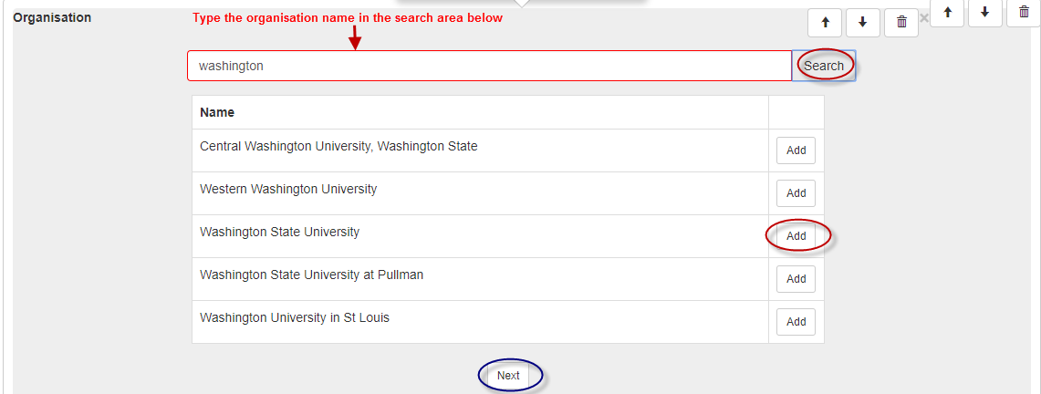

1. Select the nature of collaboration from the drop down menu and ‘Add’.   
   *(Multiple categories may be selected for each organisation).*

Nature of Collaboration List
Correspondence: eg email, telephone; or video-conference
Face to face meetings
Attendance at and/or hosting of workship or conference
Collaborative fieldwork
Hosting international Partner Investigator: short-term (less than 4 weeks)
Investigator: long-term (more than 4 weeks)
Travel to international collaborator: short-term (less than 4 weeks)
Travel to international collaborator: long term (more than 4 weeks)

1. Provide a justification of a maximum of 5000 characters detailing the benefit of the collaboration.
2. Select ‘Yes’ or ‘No’ to identify if the collaboration will continue past the life of the grant?
3. Note that only one organisation can be selected.
4. To add additional collaborations or partnerships, select ‘Add answer’ and repeat steps 2 to 6.

**Please Note:** If the organisation does not exist in RMS, provide the details (full name, country and ABN - if Australian organisation) via the link provided. If the organisation is international provide the details to the RMS Help Desk at [ARC-Systems@arc.gov.au](mailto:ARC-Systems@arc.gov.au) and the organisation will be added to RMS.

**B7. Did the project team collaborate with researchers outside their own discipline areas during this Project? (*Mandatory*)**

A ‘Yes’ or ‘No’ answer is required. If ‘Yes’, manually enter the Field of Research (FOR) numerical code or enter the appropriate category code. Refer the link below to the Australian Bureau of Statistics for the FOR classifications.

[Australian and New Zealand Standard Research Classification (ANZSRC), 2020 | Australian Bureau of Statistics (abs.gov.au)](https://www.abs.gov.au/statistics/classifications/australian-and-new-zealand-standard-research-classification-anzsrc/latest-release)

1. Select the appropriate code and ‘Add’.
2. To add additional categories, complete steps one and two.
3. If ‘No’ is selected, continue on to question B8.

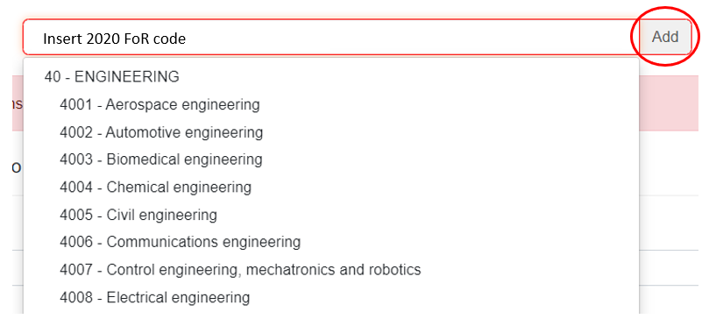

**B8. How many research students and research personnel were funded by the NISDRG grant? *(Mandatory)***

Enter the number of research students and personnel funded by the NISDRG grant. (*Refer below for definitions)*

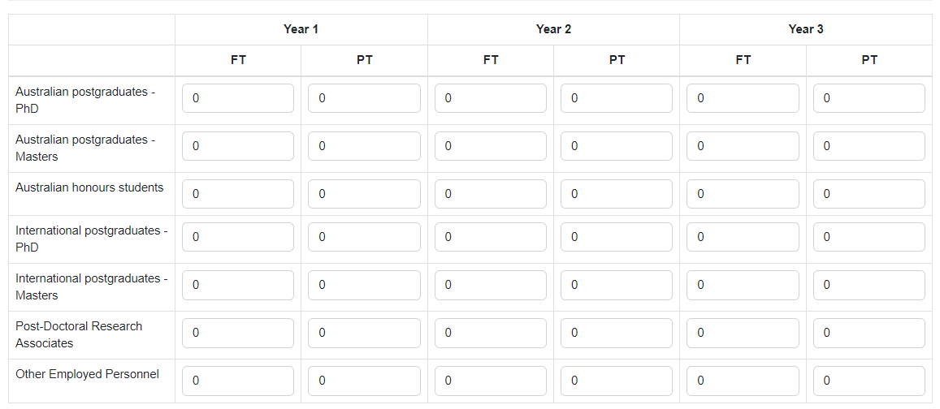

* *Australian Postgraduate, Honours and Masters* students supported by this project include; students enrolled at Australian higher education institutions whose postgraduate or honours research was assisted by the Project.
* *Overseas Postgraduate and Masters* students supported by this project include; students enrolled in overseas universities whose postgraduate or Honours research was assisted by NISDRG funding (for example, students who use equipment funded under the grant, or benefit from the Project funding).
* *Post-Doctoral Research Associates* supported by this project include; students who have a PhD or have been approved by as having a research degree or experience equivalent to the award of a PhD.
* *Other Employed Personnel* supported by this project include; research associate/assistants (full-time and part-time) funded by the Project, professional and/or technical officers and Industry Partner employees (other than named PIs) involved in the Project.

**Note:** If a student/personnel is funded for 3 years, this should be reflected per year, per student/personnel

**B9. What was the destination of students funded by the NISDRG grant (within 6-months of the conclusion of their HDR Study/project)?** (Mandatory)

Select Add answer, for each student, enter their name, year/s engaged and choose the destination from the drop-down list.

* Further study
* Industry
* Government
* University
* Other employed
* Unemployed
* Unknown.

Select “Add answer” for each individual.

**B10. Did your research project require the use of a national or international facility? *(Mandatory)***

A 'Yes’ or ‘No’ answer is required. If ‘Yes’, select Add Answer, enter the name of the facility from the drop-down menu:

* CERN
* Synchrotron – Australia
* Synchrotron – Japan
* NCRIS funded facility
* LIGO
* Other (please enter name below).

If ‘Other’ is selected, insert the name of the facility (maximum 200 characters)

* Select Yes or No to *Was this access funded by NISDRG?*
* If ‘Yes’, continue to the next question.
* If ‘No’, insert who funded the access. (maximum 200 characters).

**B11. Please list the gender breakdown of personnel (total over the project period) *(Mandatory)***

Enter the number of research students and personnel funded by the NISDRG grant. (*Refer below for definitions)*

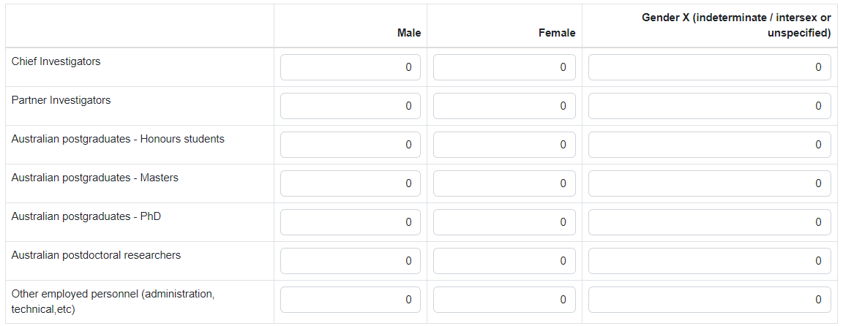

* *Chief Investigator a participant* who satisfies the eligibility criteria for a CI under these grant guidelines.
* *Partner Investigator a participant* who satisfies the eligibility criteria for a PI under these grant guidelines.
* *Australian Postgraduate and Honours students supported by this project include;* students enrolled at Australian higher education institutions whose postgraduate or honours research was assisted by the Project.
* *Overseas Postgraduate and Honours students supported by this project include;* students enrolled in overseas universities whose postgraduate or Honours research was assisted by NISDRG funding (for example, students who used equipment funded under the grant, or benefited from the Project funding).
* *Post-Doctoral Research Associates supported by this project include*; students who have a PhD or have been approved as having a research degree or experience equivalent to the award of a PhD.
* *Other Employed Personnel supported by this project include;* research associate/assistants (full-time and part-time) funded by the Project, professional and/or technical officers and Industry Partner employees (other than named PIs) involved in the Project.

# Part C – Project Outputs

Investigators are requested to detail the project outputs achieved as a result of NISDRG funding including; research outputs (C1), data outputs (C2) and commercialisation outputs (C3 and C4).

**C1. Provide details of the publications produced by this Project *(Mandatory)***

Select ‘Add answer’ to provide the details of each publication produced from the project including uploading a PDF of the publication:

* Title of publication
* Type of Publication
* Place of Publication
* Year Published or Released

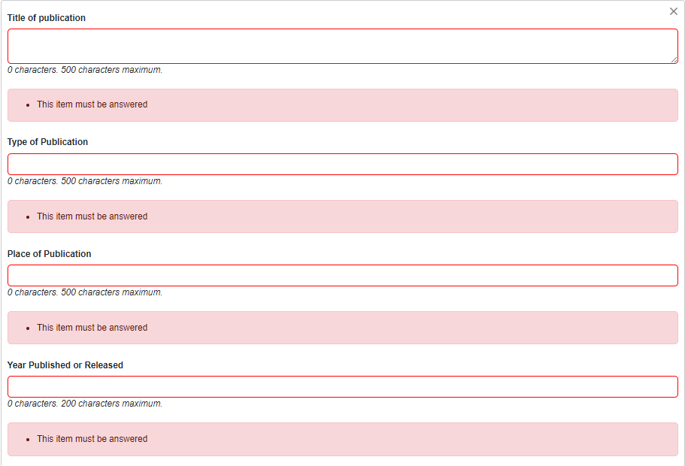

1. Select ‘Yes’ or ‘No’ from the drop down menu denoting if the publication has been made Openly Accessible within a twelve (12) month period from the publication/release date
2. If ‘**Yes**’ is selected, continue to add additional publications if required or proceed to question C2.
3. If ‘**No**’ is selected, provide an explanation as to why the publication has not been made Openly Accessible within the twelve (12) months of the publication/release date.

Please note that ‘cost’ is not an acceptable reason.

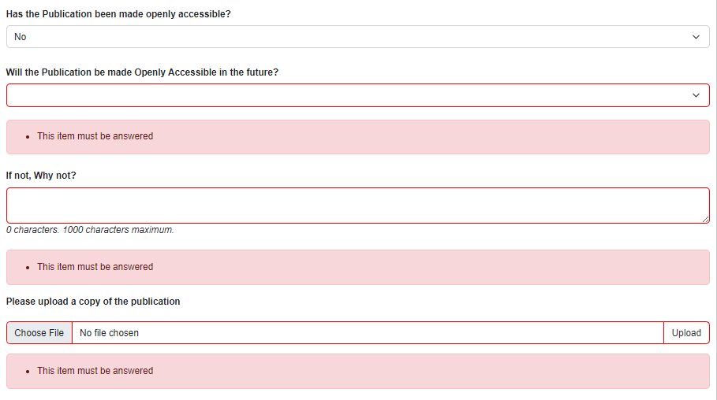

1. Select ‘Yes or ‘No’ from the drop-down list advising if the *publication will be made Openly Accessible in the future.*
2. If ‘**Yes**’, enter an expected date that the publication will be made ‘Openly Accessible’.
3. If ‘**No**’, provide an explanation as to why the publication will not be made Openly Accessible (please refer to the ARC's Open Access Policy).
4. Upload a copy of the publication, or a PDF with a link to the publication

**Please note:** It is important to ensure that any academic outputs listed in the report were produced as a result of the Project itself and that they were not produced before the start date of the Project or from other funding. If an output listed was produced before the Project’s start date it will not be taken into consideration and will be requested to be removed. We will accept approximated dates to the closest possible day/month/year of publication or release for entry in RMS if an exact publication date is unknown.

**C2. Provide details of the data outputs produced by this Project *(Mandatory)***

Details of data outputs may be provided in one of three formats:

1. Auto-populated DOI information that are already linked to the RMS DOI.
2. Auto-populate DOI number for those outputs with a DOI but are not linked to the RMS DOI.
3. Manual entry of outputs.

**Auto-populated dataset DOI information that are already linked to the RMS DOI**

If the data output has a DOI on Crossref and has been linked to the RMS DOI then they will appear automatically. To include the output to the report, select the ‘Add’ button, next to the relevant line.

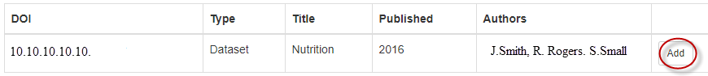

**Auto-populate dataset DOI number for those outputs with a DOI but are not linked to the RMS DOI**

1. To manually locate a dataset DOI number for population, insert the DOI number in the ‘*Search Crossref DOI’* field and select ‘Search’.



1. Select the relevant output from the list provided and select ‘Add’.
2. Once added, the dataset DOI, Type, Title, Published and Authors will auto-populate.

Search Crossref DOI by manually entering the number in the ‘Search box’ provided for auto-population of the data output.

**Manual Entry of Data Outputs**

Select ‘Add output’ and enter the following information to complete the output

* DOI number
* Output category (Dataset/Digital Data/Techniques/Algorithms/Software/Other)
* Title
* Year published/released
* Authors
* Has the Data Output been made Openly Accessible? Select ‘Yes’ or ‘No’ from the drop-down menu;

1. If ‘Yes’

* Enter the date the Data Output was made openly accessible.
* Enter where the Data Output was deposited.

1. If ‘No’

* Will the Data Output be made Openly Accessible in the Future?
* If ‘Yes’, enter the expected date that the Data Output will be made openly accessible and where the Data Output will be deposited.
* If ‘No’, provide an explanation as to why the Data Output will not be made Openly Accessible.

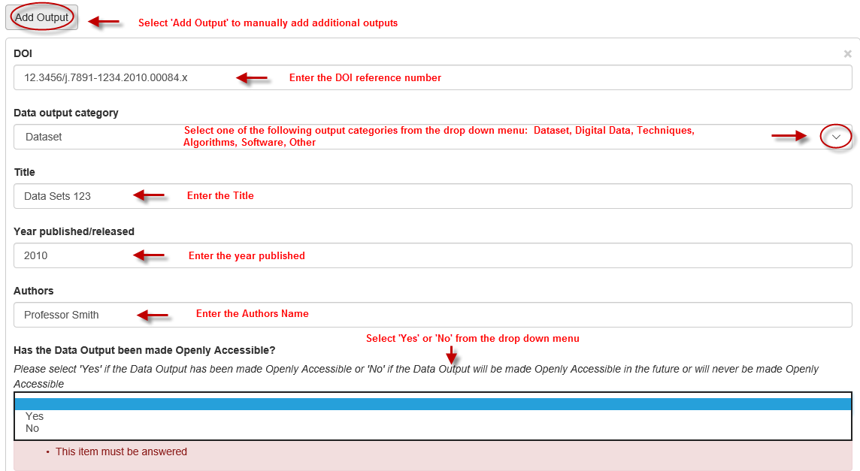

**C3. Number of commercial outputs produced during the project?**

This answer is auto-populated from the answers provided in C4 once saved.

**C4. Provide details of the commercial outputs produced by this Project** *(Mandatory)*

A Yes’ or ‘No’ answer is required for all the following questions from C4.1 - C5.

**C4.1 Invention Disclosures** *(Mandatory)*

Were any Invention Disclosures made by this Project? A ‘Yes’ or ‘No’ answer is required. If '**Yes**', provide the number of Invention Disclosures in the answer box provided.

**C4.2 Filed Patents** *(Mandatory)*

Were any Filed Patents made by this Project? A ‘Yes’ or ‘No’ answer is required. If '**Yes**' proceed to C4.2.2.

**C4.2.2 Provide details of any filed and/or pending patents**

Select the 'Add answer' button to see the fields to be completed. This must be done for each patent:

* Patent Title
* Patent Number
* Country (search for Country name and select 'Add', to add to the report)
* Application Date
* Patent Status (Filed/Pending)
* Listed on Source IP (Yes/No).

**C4.3 Plant breeders rights *(Mandatory)***

Where there any Plant Breeder Rights acquired during this Project? A ‘Yes’ or ‘No’ answer is required. If 'Yes' proceed to C4.3.2.

**C4.3.2 Provide details of any filed and/or pending patents**

Select the 'Add answer' button to see the fields to be completed. This must be done for each variety:

* Variety
* Application or certificate number
* Application Date
* Status (Filed/Certified Granted)
* Genus/Species
* Listed on Source IP (Yes/No).

**C4.4** **Registered Designs** *(Mandatory)*

Where any Registered Designs done by this Project? A ‘Yes’ or ‘No’ answer is required. If '**Yes**' proceed to C4.4.2.

**C4.4.2 Provide details of any registered designs**

Select ‘Add answer’ to see the fields to be completed . This must be done for each registered design:

* Article/Product Name
* Application Date (lodged)
* Status (Registered/Certified/Published/Lapsed/Other)
* Listed on Source IP (Yes/No).

**C4.5** **Integrated circuit design** *(Mandatory)*

Were any Integrated Designs done by this Project? A ‘Yes’ or ‘No’ answer is required. If '**Yes**' proceed to C4.5.2.

**C4.5.2 Provide details of any integrated circuit designs**

Select ‘Add answer’ to see the fields to be completed. This must be done for each circuit design:

* Name
* Details
* Listed on Source IP (Yes/No).

**C4.6** **Other IP rights** *(Mandatory)*

Were any other IP rights produced by this Project? A ‘Yes’ or ‘No’ answer is required. If '**Yes**' proceed to C4.6.2.

**C4.6.2 Provide details of any other IP**

Select ‘Add answer’ to enter the Details. Select ‘Add answer’ for each Other IP.

**C4.7** **Licensed technologies** *(Mandatory)*

Were any Licensed Technologies executed by this Project? A ‘Yes’ or ‘No’ answer is required. If '**Yes**' please enter the number of licensed technologies executed.

**C5. Did the intellectual property arrangements change during the course of the project?** *(Mandatory)*

A ‘Yes’ or ‘No’ answer is required. If ‘**Yes**’, provide details as to how the intellectual property arrangements changed during the Project and for what reasons? (Maximum 1000 characters).

**C6. Did all research outputs appropriately acknowledge ONI as required?** *(Mandatory)*

A ‘Yes’ or ‘No’ answer is required. If ‘**No’**, provide details as to why the ONI was not acknowledged.

# Part D – Project Outcomes

**D1. Briefly describe the most significant results, outcomes and benefits arising from the project. (This information is not for public release.)** *(Mandatory)*

Provide a written summary of no more than 5000 characters per question in the text boxes provided as identified below, describing the significance, results, benefits, outcomes and impacts arising from the Project.

* Contributions to existing field
* Discoveries made
* Importance of research conducted
* Innovations, for example use of new, untested methods or theories
* The 3 most promising new research directions identified
* the next steps for the research to pursue the new direction/s identified.

**Please Note:** Do not include Academic outputs in this question. These should be included in Part C – Research outputs.

**D2. Briefly describe any other commercial outcomes from the Project** *(Mandatory)*

In the text box provided, please provide a written summary of no more than 5000 characters, describing any commercial products and revenue, spin off and start-up companies, benefits to partner organisations.

**D3. Provide details of any start-up/spin-out companies formed from this Project***(Not Mandatory)*

Select ‘Add answer’ to enter each start-up/spin-out companies details:

* Company/business name
* Australian Business Number (do not enter spaces)
* Year Established
* Number of current employees
* Company website/URL.

**D4. Provide details of research activities or grants (funded or applied for) resulting from this Project** *(Not Mandatory)*

Select ‘Add answer’ to enter each research activity or grant (funded or applied for) resulting from the Project:

* Grant Opportunity name
* Participants
* Research activities
* Funding requested/approved

**D5. Have any of the investigators or their works won prizes, awards or other major tributes as a result of the research Project?** *(Mandatory)*

A ‘Yes’ or ‘No’ answer is required. If '**Yes**' proceed to D5.2.

**D5.2 Provide details of prizes, awards or major tributes by completing the following questions:**

Select ‘Add answer’ to enter each award or major tribute received.

* Award title / name
* Type of prize/award (select one of the following from the drop-down menu)
* Australian Government
* International Government
* No-government / Intergovernmental Organisation
* Peak body – Academies, Societies, etc.
* Industry and other private funding
* Researcher’s own institution
* Awarded to (select from drop-down menu and ‘Add’)
* Description / awarded by
* Date awarded

**D6. What have you done to facilitate dissemination of the outcomes of your research?** *(Mandatory)*

From the drop-down menu, select the appropriate knowledge mobilisation event or activity and select ‘Add’.

* Media Coverage
* Press Release
* Project Relates Websites
* School Outreach
* Public Lectures/Forums
* Exhibitions
* Social Media
* Other.

Multiple activities can be selected.

1. For Media release links, please provide a link to the relevant page in the text box provided.
2. If ‘Other’ is selected, please specify within the text box provided.

# Part E – Research Impacts

**E1. Outline how the completed project has enhanced fundamental research in relation to the Intelligence Challenge/s addressed.** *(Mandatory)*

Select ‘Add answer’ to enter the details for each Challenge.

1. From the drop-down menu, select the Challenge selected in the original proposal and select ‘Add’
2. Enter the Challenge Statement from the Proposal
3. Describe how the completed Project has addressed the Challenge
4. For additional Challenges select ‘Add answer’.

**E2. Provide details of the likely benefits arising from your research project** *(Mandatory)*

Outline how your research project has built collaboration with the science and technology community that supports Australia’s National Intelligence Community, and supported systematic and coordinated engagement between the research community, science and technology community and Australia’s National Intelligence community. (Maximum 1000 characters)

Answer the following questions by selecting the relevant options from the drop-down menu. Select the appropriate category and ‘Add’. Multiple answers may be selected for these options.

**My Research has produced or is likely to result in or lead to** (Multi-select options)

* Benefits to the Australian Research activity capacity and expertise in relevant areas
* Greater use and awareness of open-source research information
* Improved knowledge in intelligence and security related science and technology innovation in the national intelligence community
* Improved understanding of potential future intelligence and security capability
* Improved knowledge and expertise to inform government ability to lead development of intelligence and security science and technology
* Systematic and coordinated engagement with science and technology community and industry
* Increased numbers of researchers in priority areas
* Other-provide details below.

If ‘Other – provide details below’ is selected, please provide further details in the ‘Other benefits’ text box provided.

**I expect the benefit will be realised** (Single selection only)

* Already achieved
* Within five years
* More than five years.

**My research will benefit** (Multi-select option)

* Academic sector
* General public
* Government
* Not-for-profit/community organisations
* Schools
* Hospitals
* Private sector companies
* Professional & Industrial associations
* Galleries/libraries and museums sector
* Partner Organisations
* Other.

If ‘Other’ is selected from the options above, please specify whom the research will benefit.

**E3. Global Context** *(Mandatory question)*

Provide a comment addressing the global context of how the completed project fits within the international scene regarding the enhancement of Australian Intelligence and National Security Capabilities and Building Research.

# Part F – Budget and expenditure

**F1. Were Grant funds spent as expected in the original Proposal?** *(Mandatory question)*

Please upload the final project expenditure by category, and the cash and in-kind contributions for all organisations. Upload the template Activity *Budget – Final Report table* from the [Resource Hub | Research Grants Services](https://www.researchgrants.gov.au/resource-hub/nisdrg-final-report-activity-budget) in PDF format. Provide commentary of any changes to the Projects expenditure and organisational contributions from the original application.

**F2. Equipment** *(Mandatory question)*

Were Grant funds used to purchase equipment for this Project? A ‘Yes’ or ‘No’ answer is required. If '**Yes**'

* Describe the equipment purchased
* How will this equipment be used now that the project is complete?

Select ‘Add answer’ for each additional piece of equipment.

**Form completion**

Once all questions in the report have been completed and all form parts are green, the report can be submitted as detailed on Submission of Final Reports: Information to note

